SID: 014488487

Name: Vamsi Krishna Chakravartula

Video Link: <https://youtu.be/FzT8iPC3GZs>

Report

**Introduction: State your goals and purpose of the system**

Aim of the project is to design a prototype of the popular review and ordering system ‘Yelp’ , replicating a subset of features that include restaurant reviews, customer database, image support, food ordering and messaging. The goal of the project is to get an exposure to multiple technologies and also the practice of industry standards of coding.

**System Design: Describe your chosen system design**

Used ReactJS, Redux, Bootstrap and CSS for the development of UI in the web application. NodeJS is used for the backend services with the database being MongoDB with the atlas version. Messaging system is also implemented using Kafka. Deployed the application on AWS EC2 instances with separate servers of frontend and backend. Used Amazon S3 for image storage

**Tech Stack:**

Frontend: React, Redux, Bootstrap, CSS

Backend: Node

Database: MongoDB

Image storage: Amazon AWS S3

Authentication: PassportJS, JWT

Testing: Mocha, Enzyme, Jmeter

Messaging System: Kafka

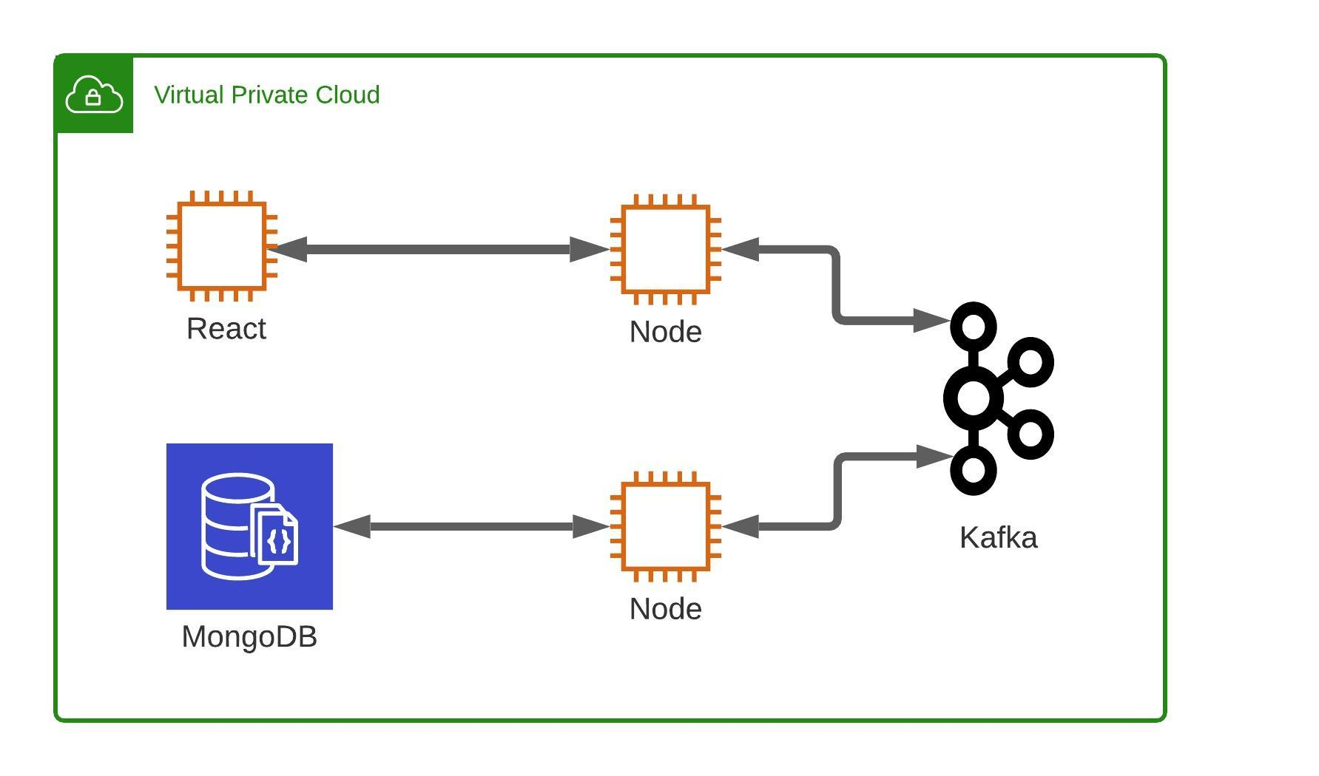

**o Results: Screen captures of testing results and important screens of the application.**

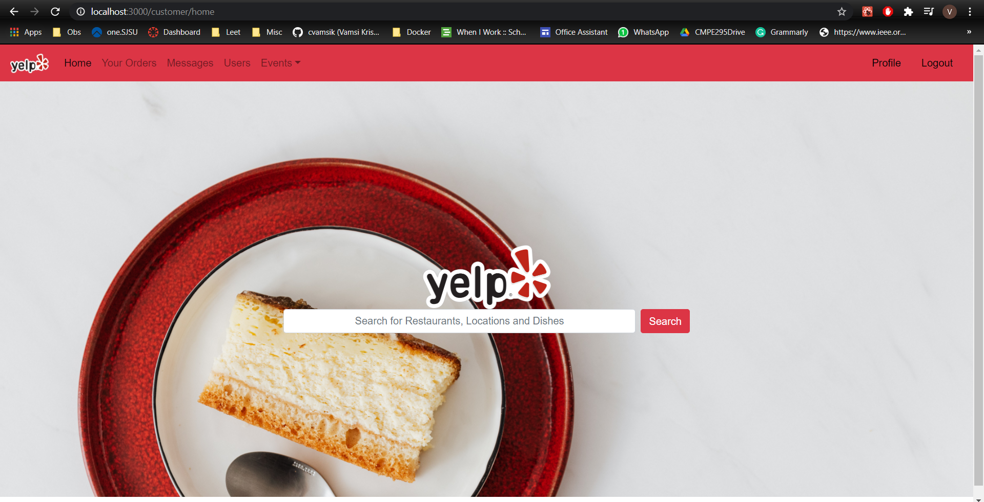

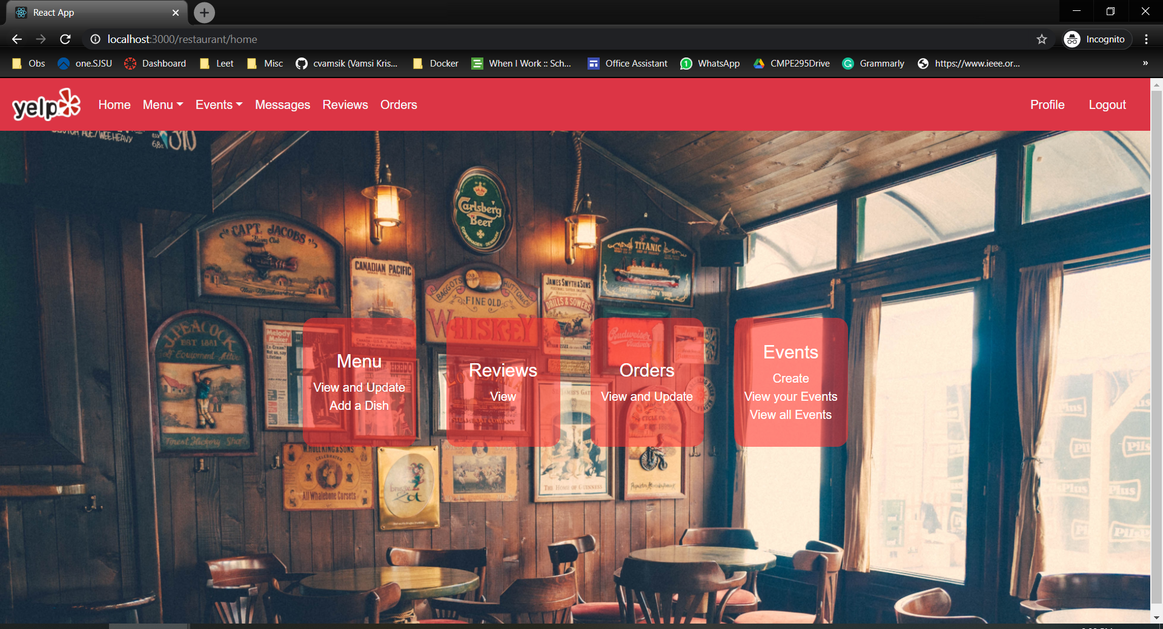

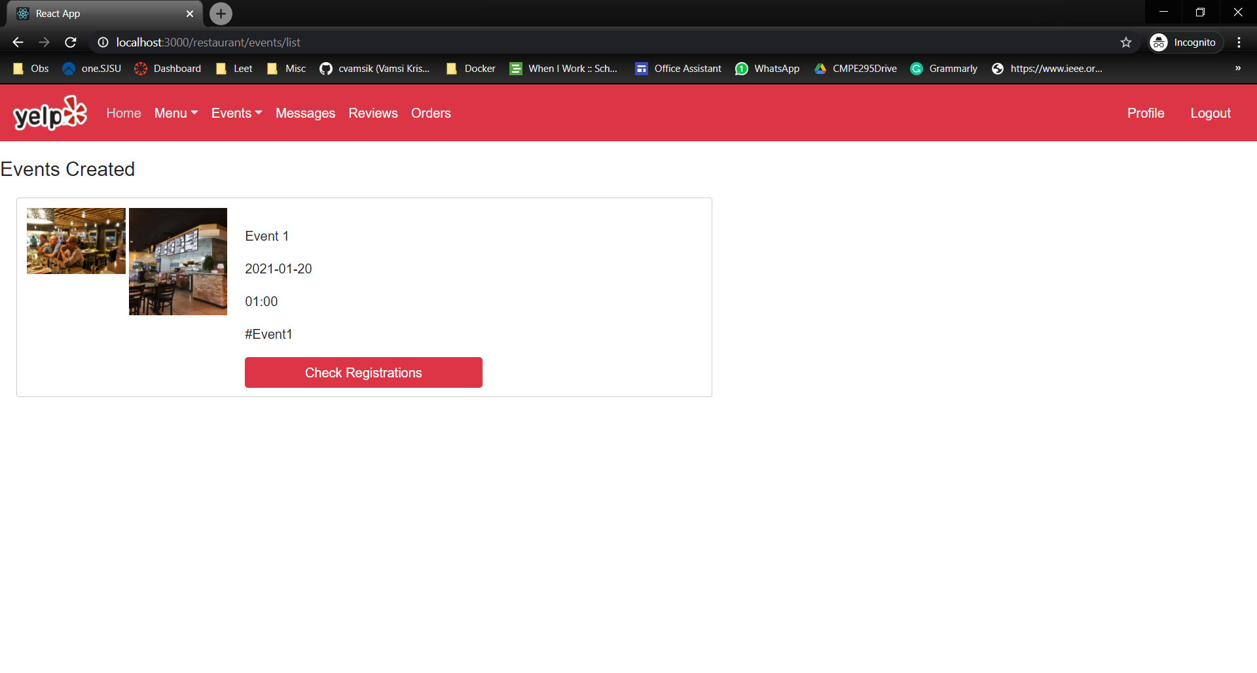

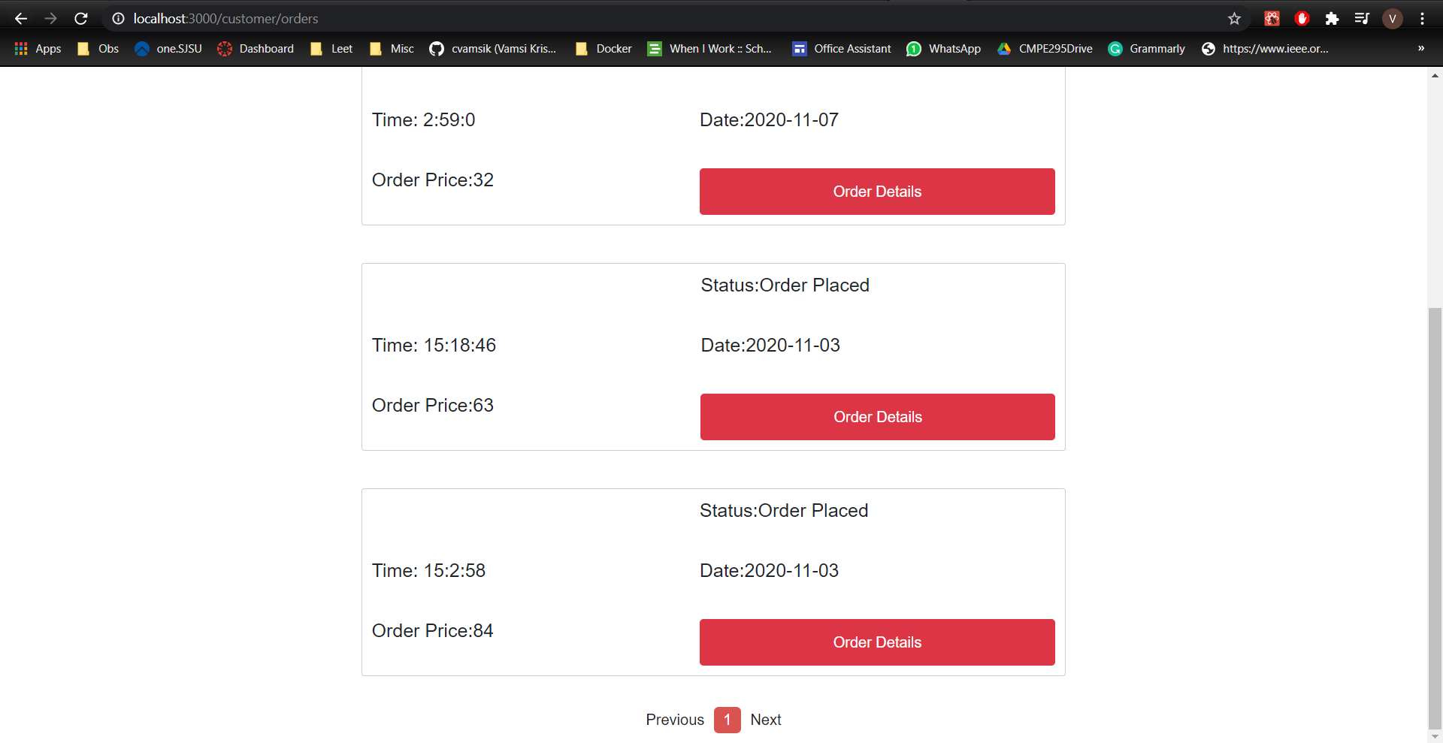

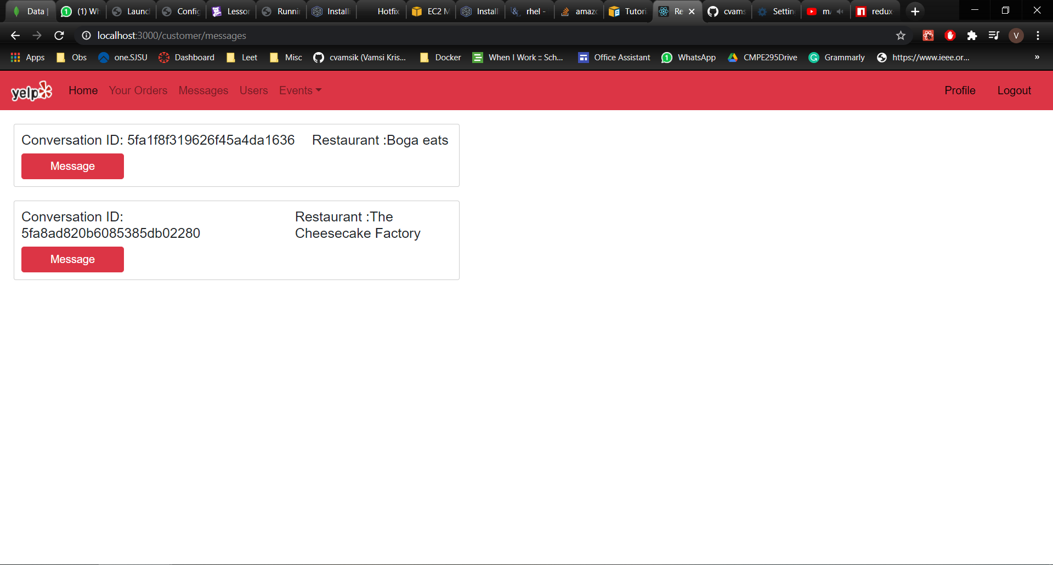

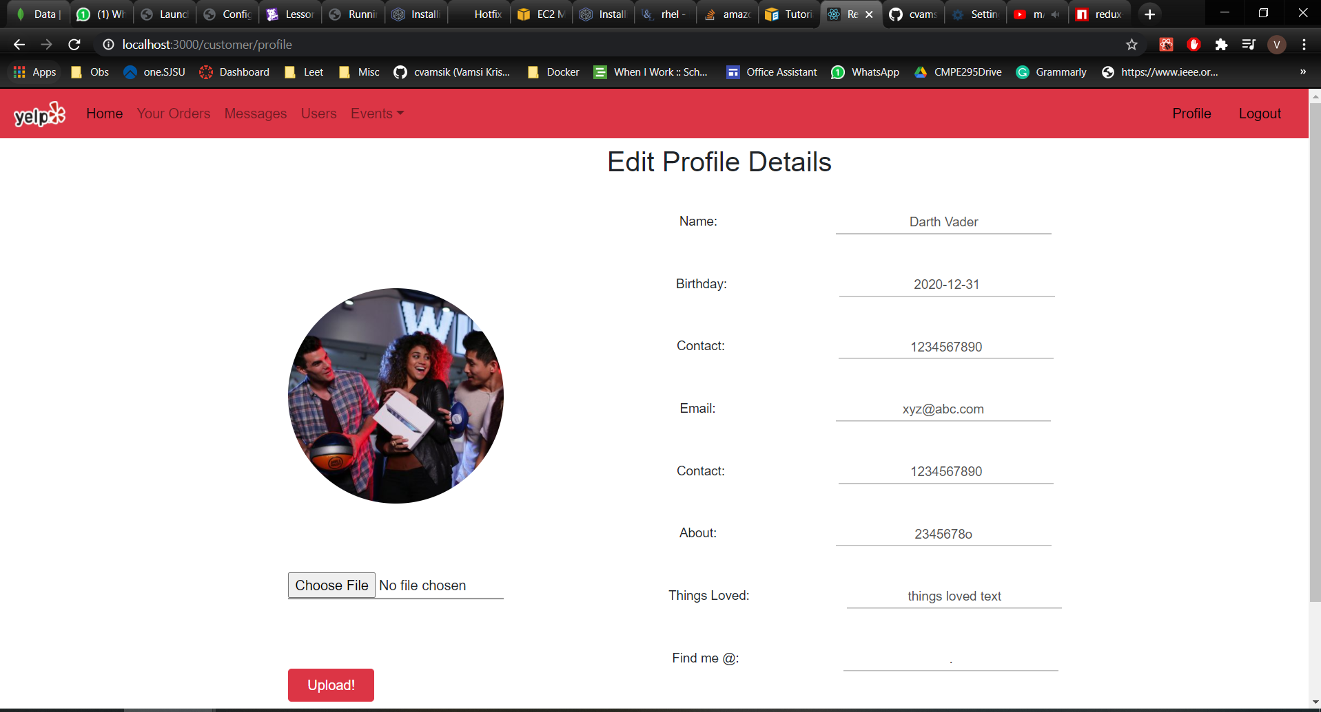

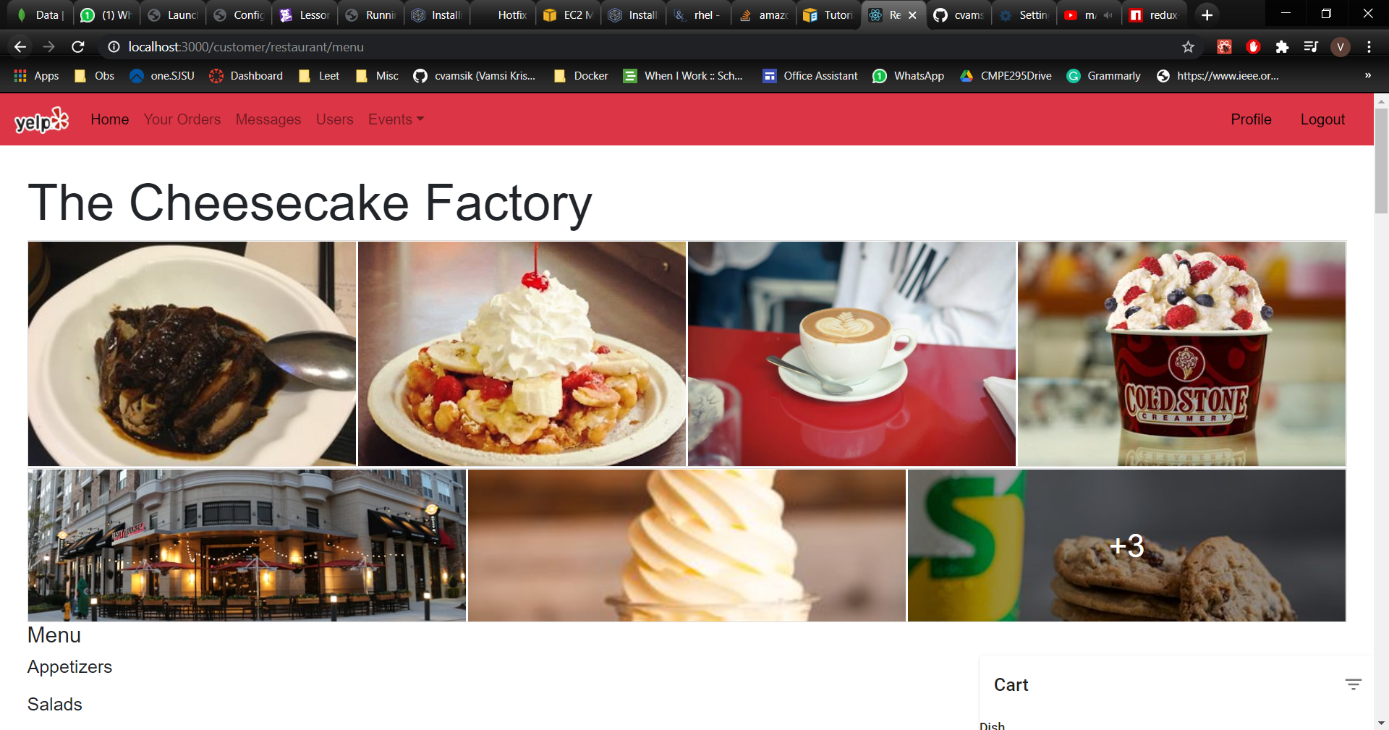

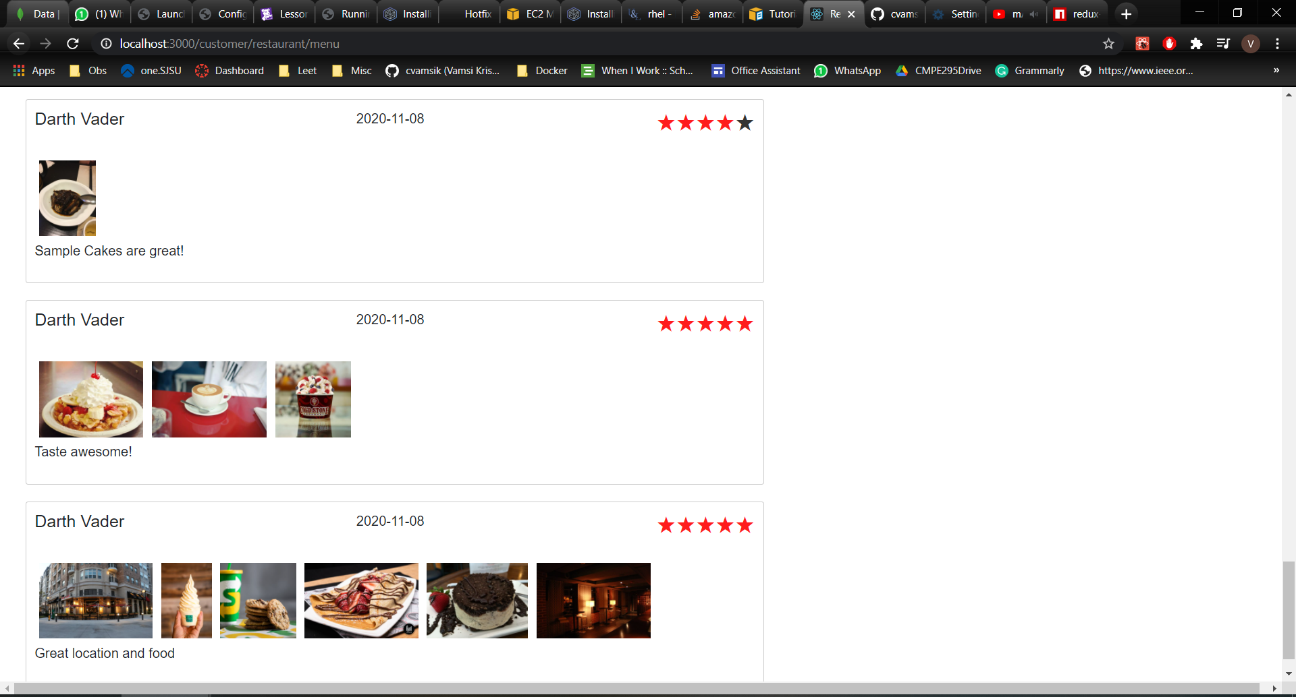

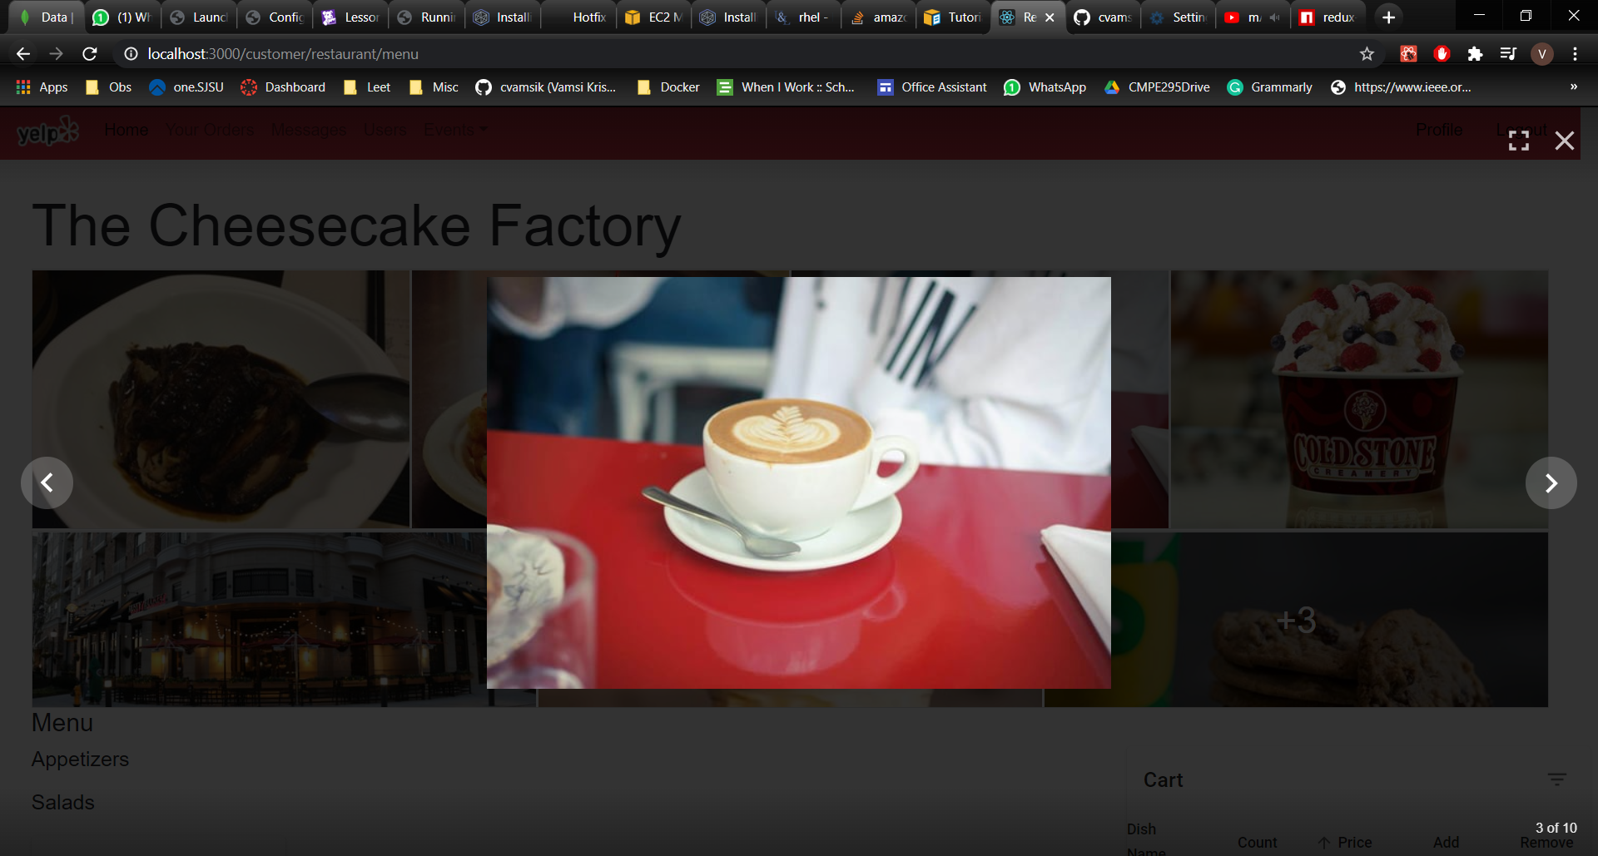

**Testing**

**Mocha:**

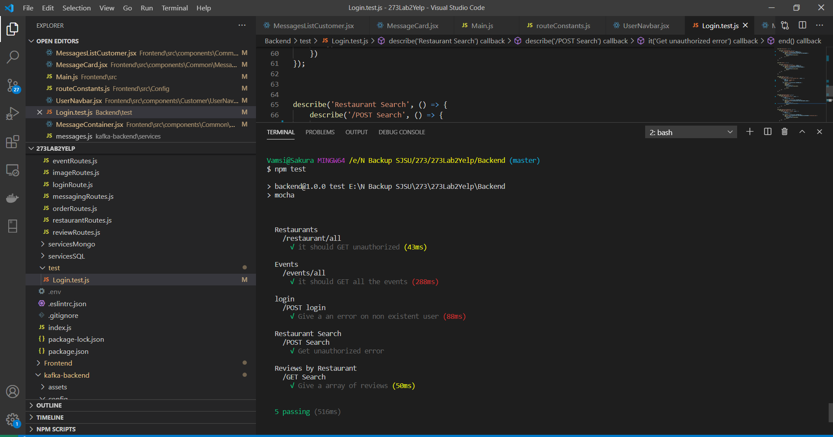

**Enzyme:**

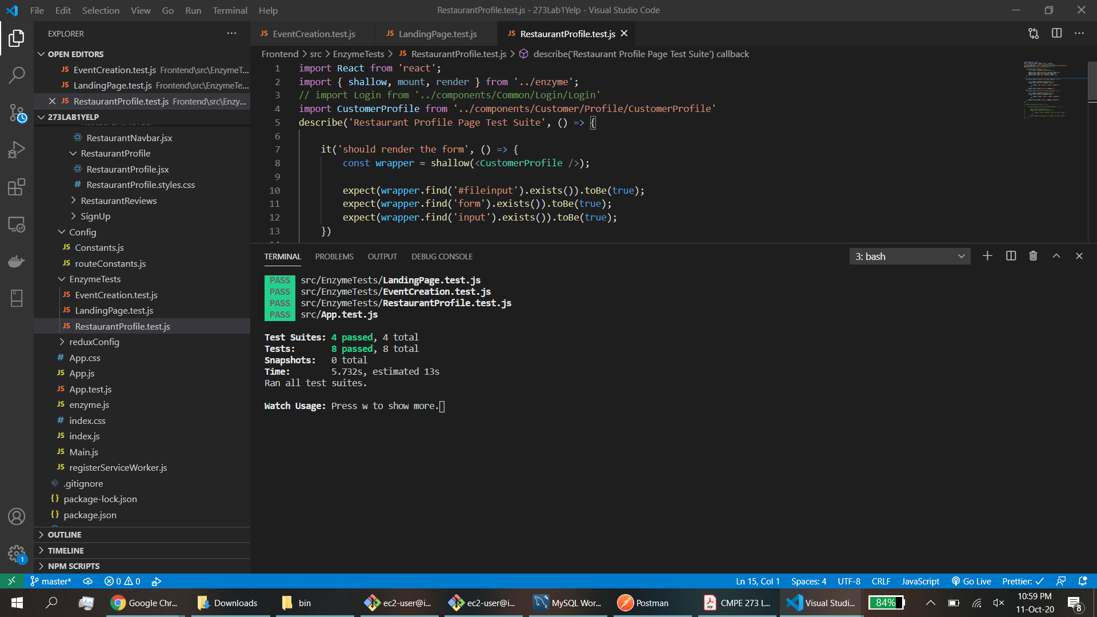

**WITH CONNECTION POOLING:**

**100:**

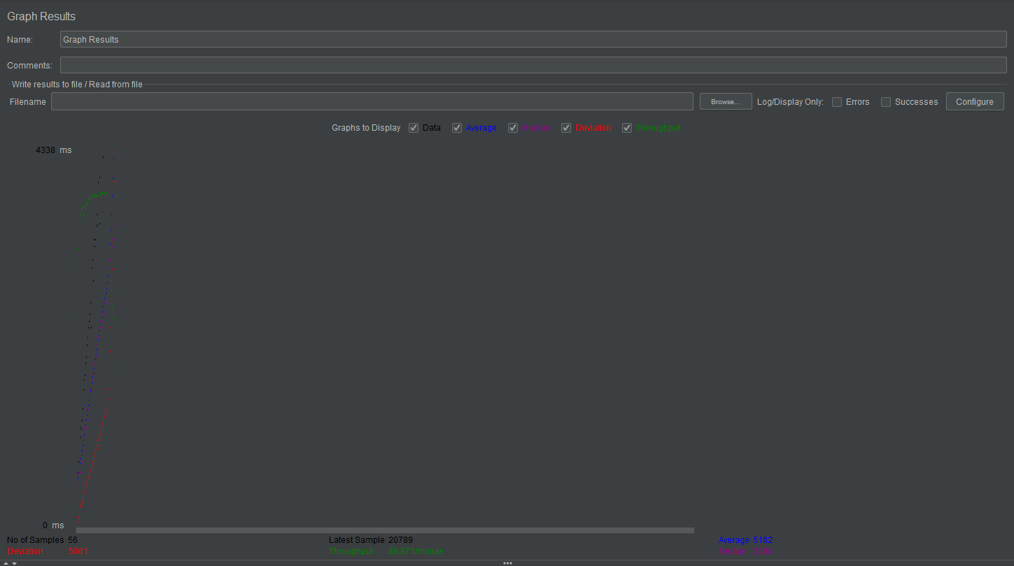

**200:**

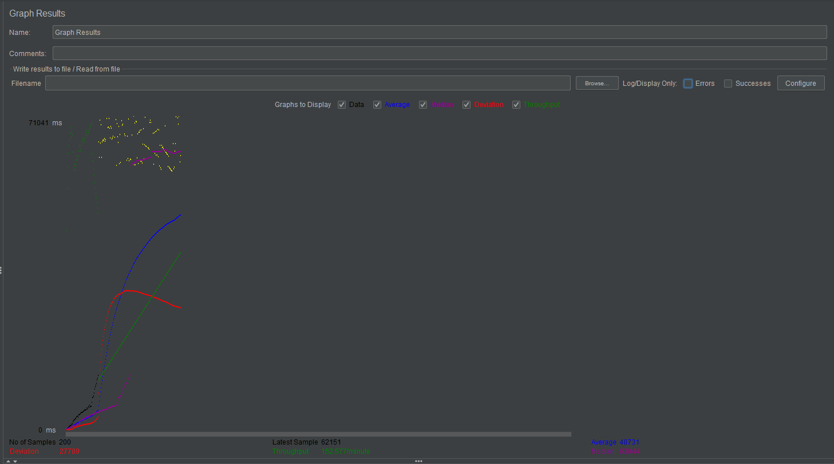

**300:**

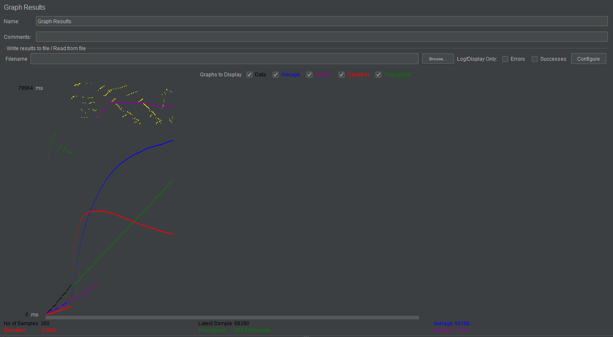

**400:**

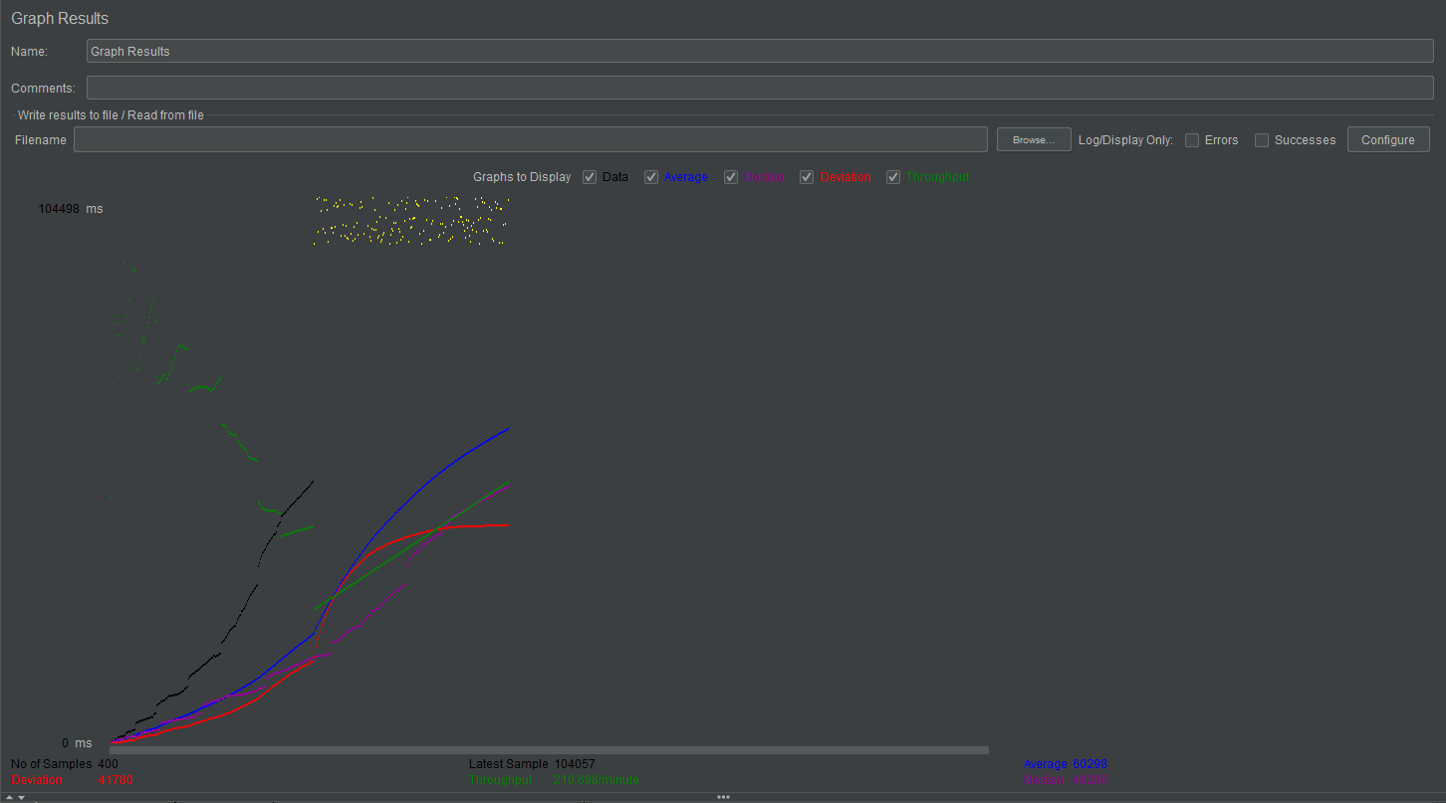

**500:**

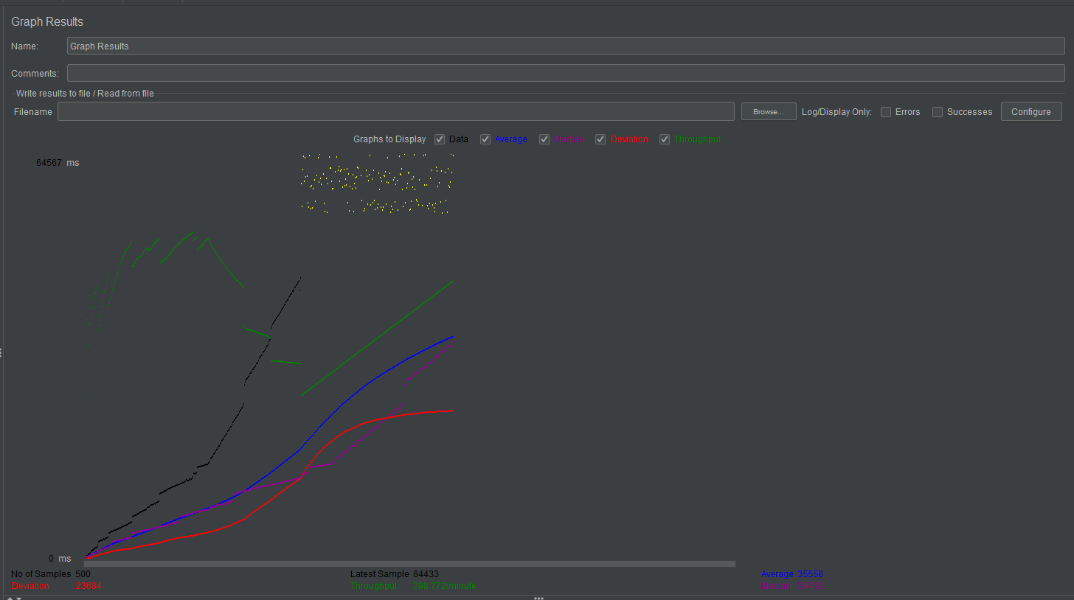

**WITHOUT CONNECTION POOLING:**

**100:**

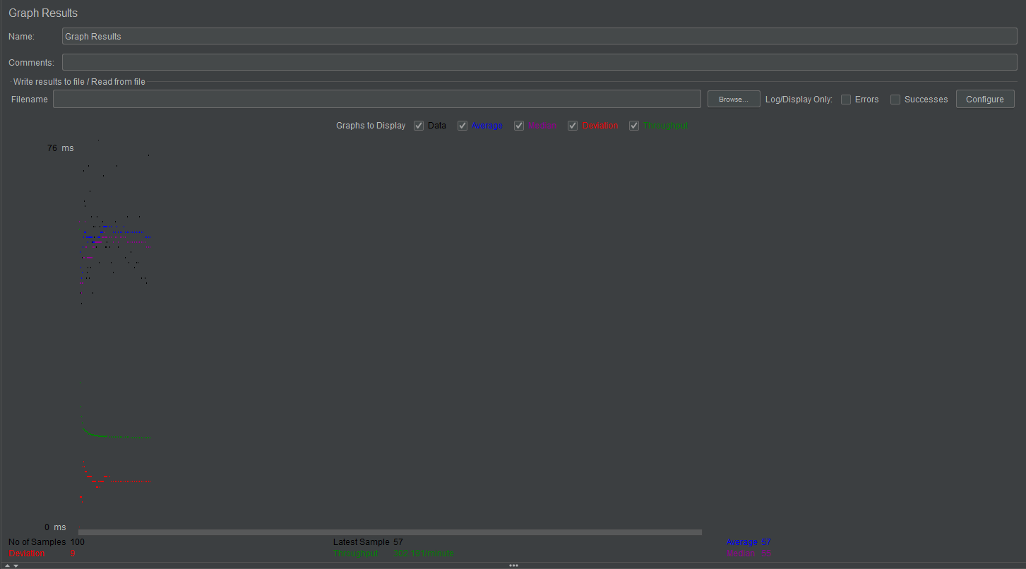

**200:**

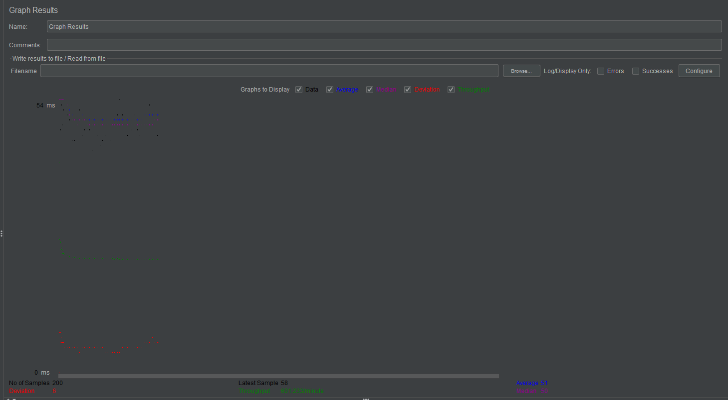

**300:**

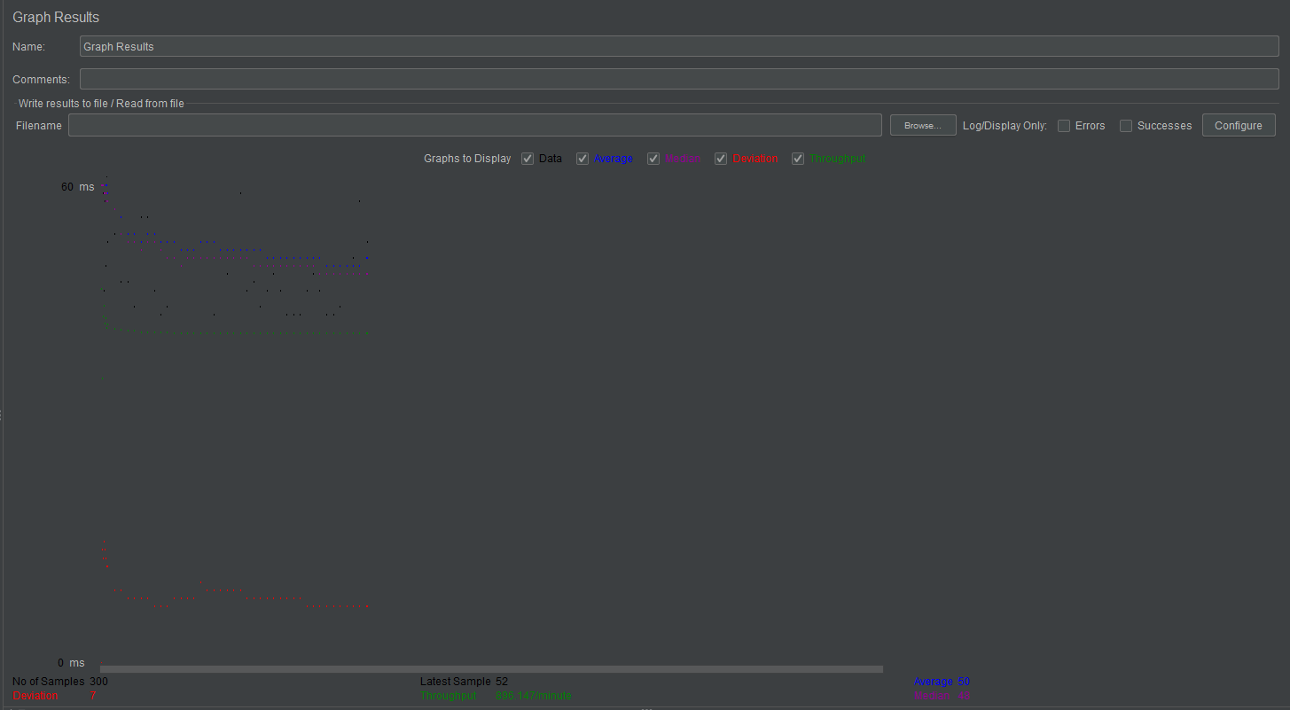

**400:**

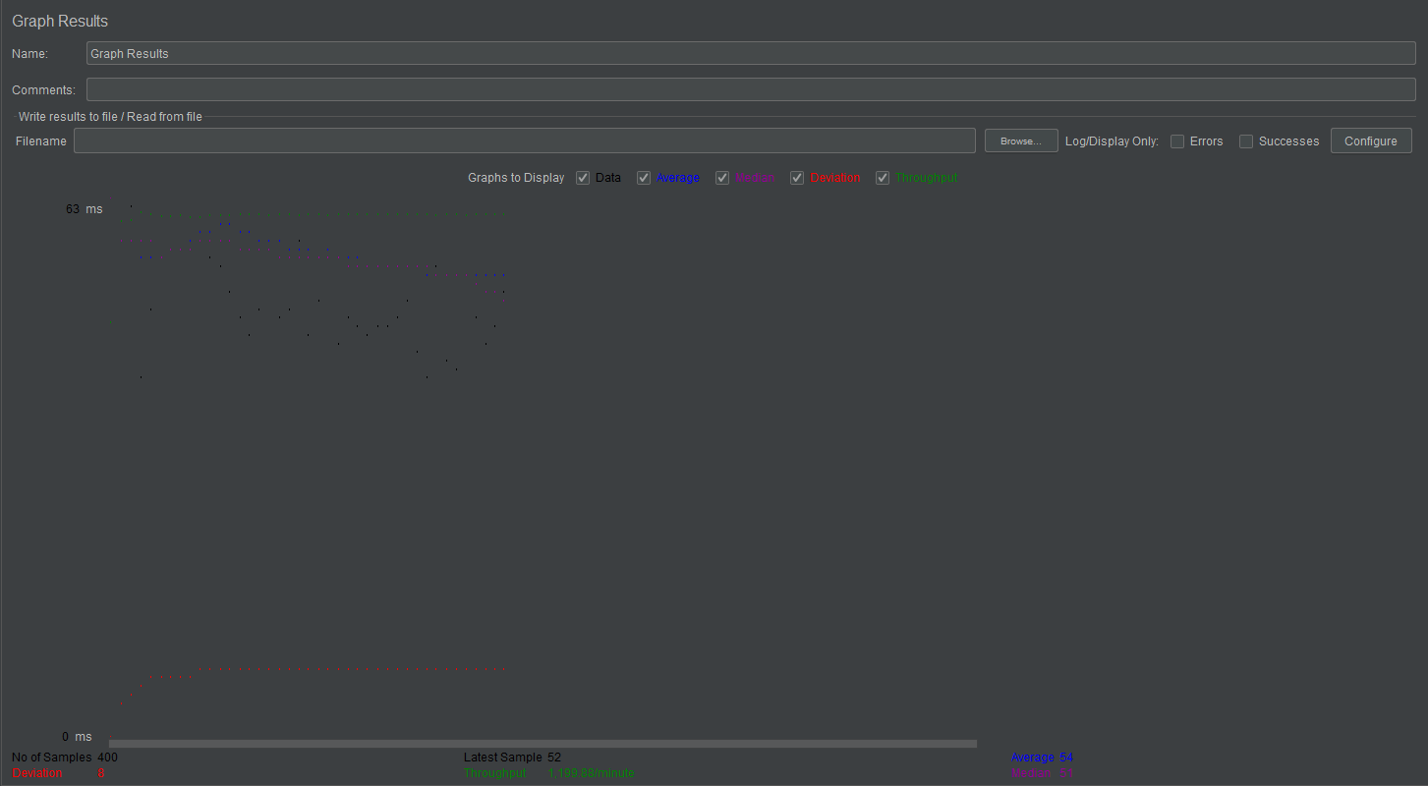

**500:**

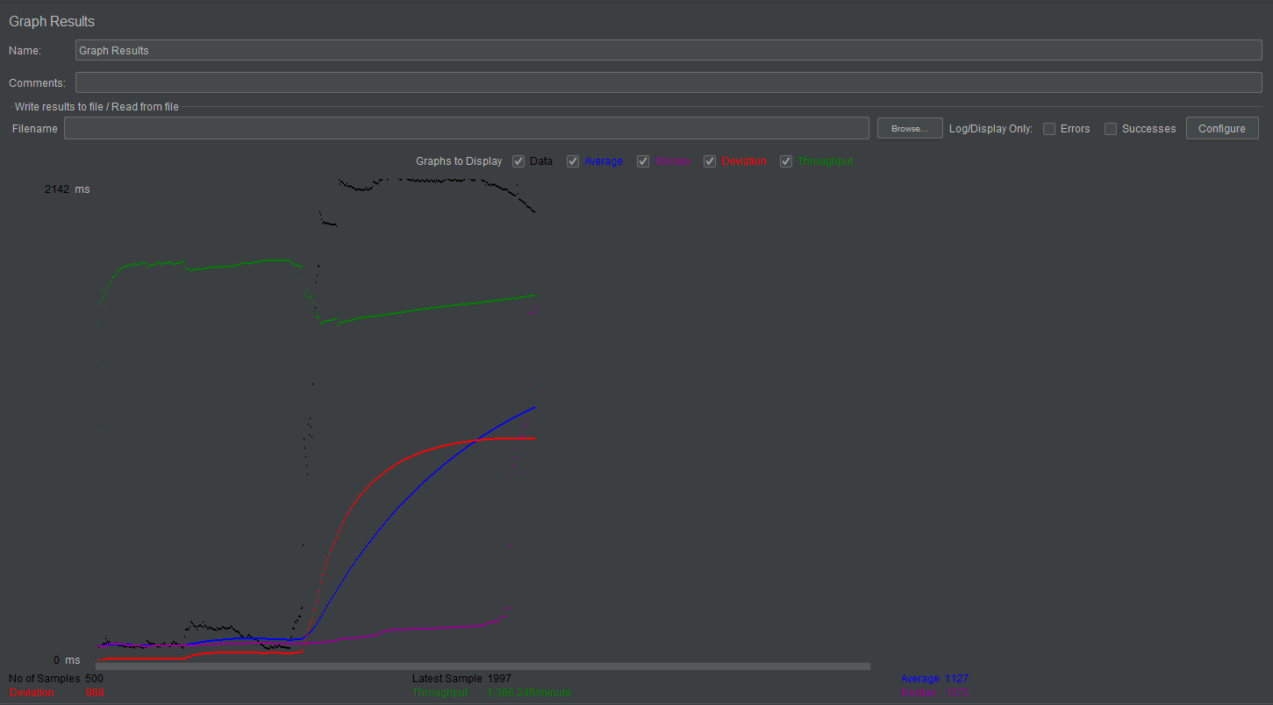

**o Performance: What was performance? Analyze results and explain why you are getting those results.**

With Kafka in place, the throughput is in accordance with the increase in the concurrent users, which ramps up over a set time period. It increases with the connection pooling and decreases with the pooling switched off in the connection with MongoDB

**o Git Commit history – screen capture**

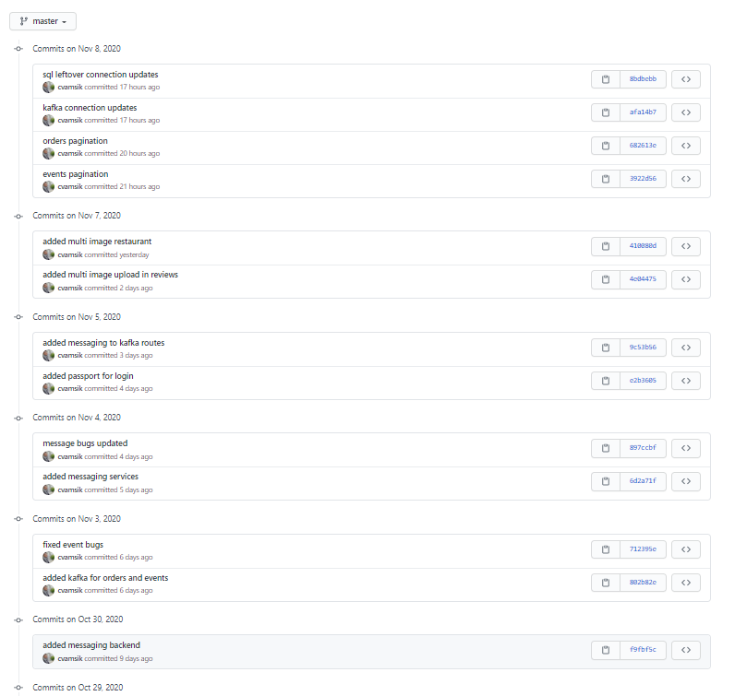

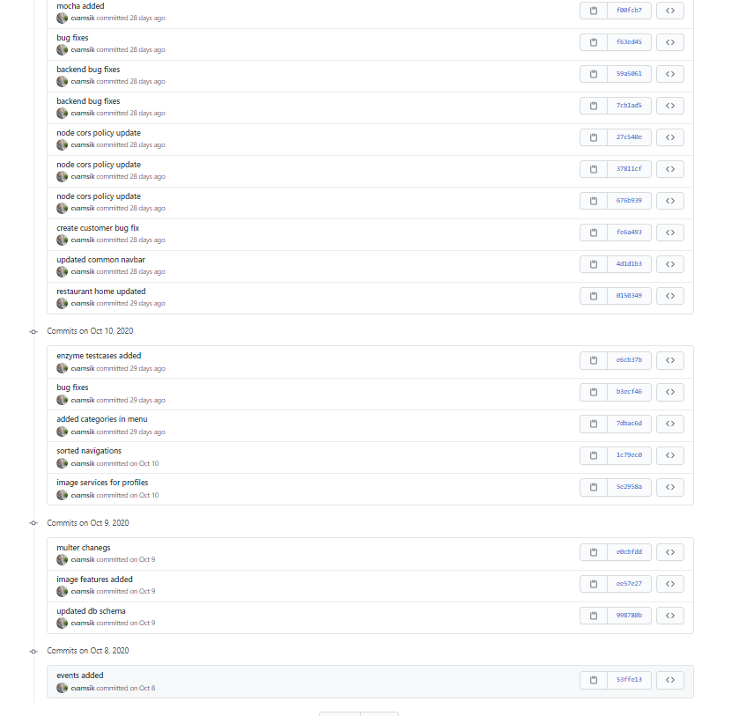

**o Answers to the questions.**

**1. Compare passport authentication process with the authentication process used in Lab1.**

Ans. Lab 1 used basic password encryption and authentication using cookies. The backend server would send cookies with expiry times that would help in keeping the user authenticated. It is not very secure and does not protect the APIs.

Lab 2 uses PassportJS with Javascript Web Tokens (JWT) as the authentication mechanism. This is a robust and provides stricter security to the access to backend APIs. Every time a user logs in, a JWT is sent as a response, which is stored in the browser. This JWT is a mandate authorization token while accessing the API calls. Thus, these tokens can be valuable in increasing the authentication factor.

**2. Compare performance with and without Kafka. Explain in detail the reason for difference in performance.**

Kafka is a messaging system that is used in distributed environments to scale the applications horizontally. It increases the fault tolerance of the application, while increasing the throughput in the message handling part. Although Kafka proves to be a very good addition in a large scale application, it would prove inefficient in smaller scale applications, which are not distributed and have a lower request rate. It adds to the overload of maintaining the Kafka and zookeeper servers and the processing time of them.

**3. If given an option to implement MySQL and MongoDB both in your application, specify which part of data of the application you will store in MongoDB and MySQL respectively**

MySQL has a more secure property while storing the data and can be used to store data that would not need high normalization as JOINS would lead to lower performance of the database. On the other hand, MongoDB has a faster and fault tolerant architecture which uses sharding. This can be useful when storing non-relational data in the form of documents. If implementing both the databases, the user credentials would be a good example of dataset to be stored in MySQL while the rest of restaurant data will fit better with MongoDB.